5. Height Balanced Trees

(AVL Trees)
Aim:
Operations on AVL Trees

Theory:
AVL tree is a self-balancing Binary Search Tree (BST) where the difference between heights of left and right subtrees cannot be more than one for all nodes.
In an AVL tree, the heights of the two child subtrees of any node differ by at most one; if at any time they differ by more than one, rebalancing is done to restore this property. Lookup, insertion, and deletion all take O(log n) time in both the average and worst cases, where n is the number of nodes in the tree prior to the operation. Insertions and deletions may require the tree to be rebalanced by one or more tree rotations.
The AVL tree is named after its two Soviet inventors, Georgy Adelson-Velsky and Evgenii Landis, who published it in their 1962 paper "An algorithm for the organization of information".
Most of the BST operations (e.g., search, max, min, insert, delete.. etc) take O(h) time where h is the height of the BST. The cost of these operations may become O(n) for a skewed Binary tree. If we make sure that height of the tree remains O(log n) after every insertion and deletion, then we can guarantee an upper bound of O(log n) for all these operations.

AVL Tree Insertion:
Let the newly inserted node be w
1) Perform standard BST insert for w.
2) Starting from w, travel up and find the first unbalanced node. Let z be the first unbalanced node, y be the child of z that comes on the path from w to z and x be the grandchild of z that comes on the path from w to z.
3) Re-balance the tree by performing appropriate rotations on the subtree rooted with z. There can be 4 possible cases that needs to be handled as x, y and z can be arranged in 4 ways. Following are the possible 4 arrangements:
- y is left child of z and x is left child of y (Left Left Case)
- y is left child of z and x is right child of y (Left Right Case)
- y is right child of z and x is right child of y (Right Right Case)
- y is right child of z and x is left child of y (Right Left Case)

In all of the cases, we only need to re-balance the subtree rooted with z and the complete tree becomes balanced as the height of subtree (After appropriate rotations) rooted with z becomes same as it was before insertion.
a) Left Left Case
T1, T2, T3 and T4 are subtrees.
z y
/ \ / \
y T4 Right Rotate (z) x z
/ \ - - - - - - - - -> / \ / \
x T3 T1 T2 T3 T4
/ \
T1 T2
b) Left Right Case
z z x
/ \ / \ / \
y T4 Left Rotate (y) x T4 Right Rotate(z) y z
/ \ - - - - - - - - -> / \ - - - - - - - -> / \ / \
T1 x y T3 T1 T2 T3 T4
/ \ / \
T2 T3 T1 T2
c) Right Right Case
z y
/ \ / \
T1 y Left Rotate(z) z x
/ \ - - - - - - - -> / \ / \
T2 x T1 T2 T3 T4
/ \
T3 T4
d) Right Left Case
z z x
/ \ / \ / \
T1 y Right Rotate (y) T1 x Left Rotate(z) z y
/ \ - - - - - - - - -> / \ - - - - - - - -> / \ / \
x T4 T2 y T1 T2 T3 T4
/ \ / \
T2 T3 T3 T4
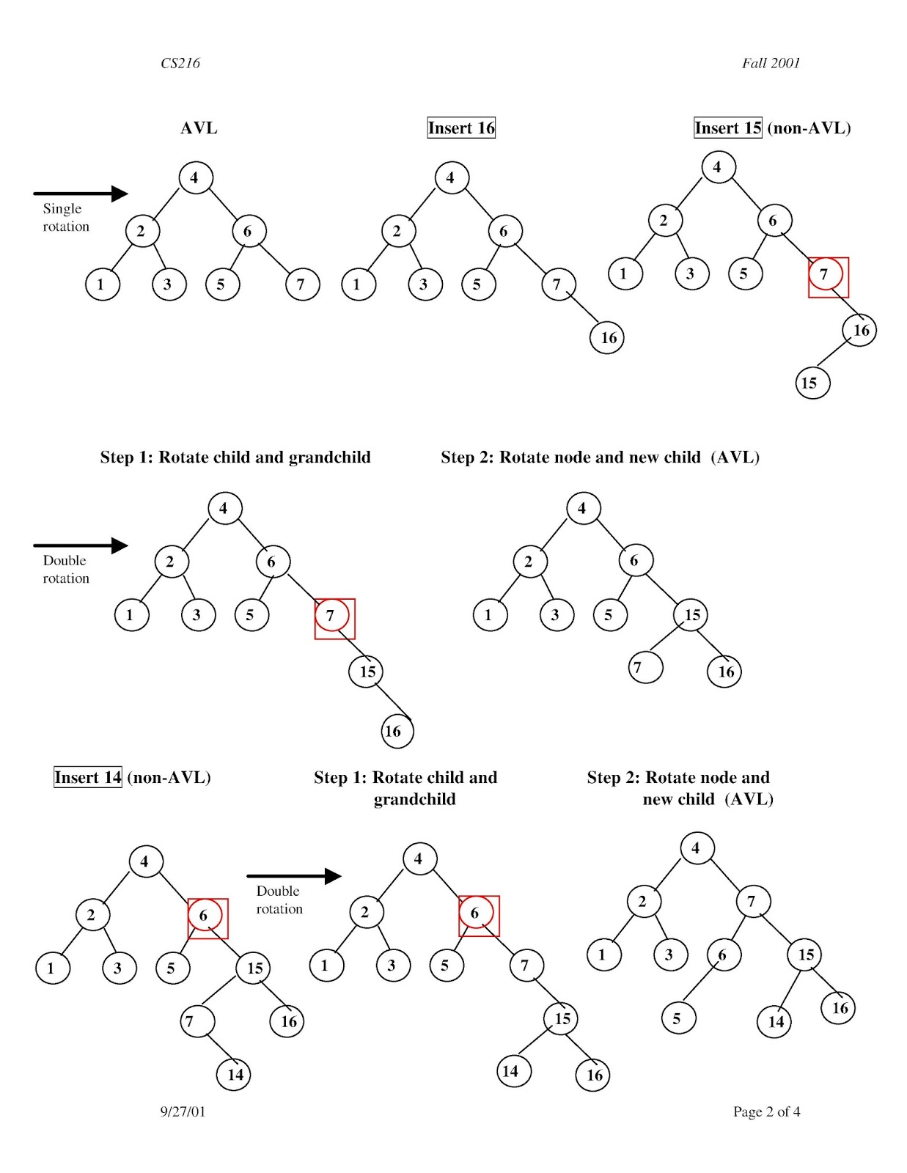Figure 1: AVL Tree Insertion Example

AVL Tree Deletion:
Let w be the node to be deleted
1) Perform standard BST delete for w.
2) Starting from w, travel up and find the first unbalanced node. Let z be the first unbalanced node, y be the larger height child of z, and x be the larger height child of y. Note that the definitions of x and y are different from insertion here.
3) Re-balance the tree by performing appropriate rotations on the subtree rooted with z. There can be 4 possible cases that needs to be handled as x, y and z can be arranged in 4 ways. Following are the possible 4 arrangements:
a) y is left child of z and x is left child of y (Left Left Case)
b) y is left child of z and x is right child of y (Left Right Case)
c) y is right child of z and x is right child of y (Right Right Case)
d) y is right child of z and x is left child of y (Right Left Case)
Like insertion, following are the operations to be performed in above mentioned 4 cases. Note that, unlike insertion, fixing the node z won’t fix the complete AVL tree. After fixing z, we may have to fix ancestors of z as well.
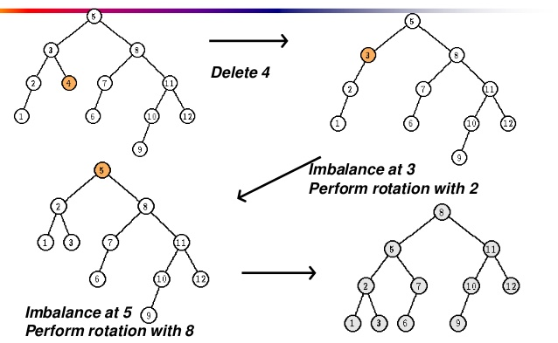Figure 2: AVL Tree Deletion Example

Program:
#include<stdio.h>
#include<stdlib.h>

struct Node
{
int key;
struct Node *left;
struct Node *right;
int height;
};

int max(int a, int b)
{
return (a > b)? a : b;
}

int height(struct Node *N)
{
if (N == NULL)
return 0;
return N->height;
}

struct Node* newNode(int key)
{
struct Node* node = (struct Node*)
malloc(sizeof(struct Node));
node->key = key;
node->left = NULL;
node->right = NULL;
node->height = 1; // new node is initially added at leaf
return(node);
}

struct Node *rightRotate(struct Node *y)
{
struct Node *x = y->left;
struct Node *T2 = x->right;

x->right = y;
y->left = T2;

y->height = max(height(y->left), height(y->right))+1;
x->height = max(height(x->left), height(x->right))+1;

return x;
}

struct Node *leftRotate(struct Node *x)
{
struct Node *y = x->right;
struct Node *T2 = y->left;

y->left = x;
x->right = T2;

x->height = max(height(x->left), height(x->right))+1;
y->height = max(height(y->left), height(y->right))+1;

return y;
}

int getBalance(struct Node *N)
{
if (N == NULL)
return 0;
return height(N->left) - height(N->right);
}

struct Node* insert(struct Node* node, int key)
{
/* 1. Perform the normal BST insertion */
if (node == NULL) {
printf("\nNODE IS NULL");
return(newNode(key));
}
if (key < node->key) {
printf("\nMOVE LEFT");
node->left = insert(node->left, key);
}
else if (key > node->key) {
printf("\nMOVE RIGHT");
node->right = insert(node->right, key);
}
else { // Equal keys are not allowed in BST
printf("\nEQUAL KEYS NOT ALLOWED");
return node;
}

/* 2. Update height of this ancestor node */
node->height = 1 + max(height(node->left),
height(node->right));
printf("\nHEIGHT OF NODE --> %d",node->height);
/* 3. Get the balance factor of this ancestor
node to check whether this node became
unbalanced */
int balance = getBalance(node);
printf("\nBALANCE FACTOR FOR NODE %d --> %d",node->key,balance);

// Left Left Case
if (balance > 1 && key < node->left->key)
{
printf("\nLEFT LEFT CASE");
return rightRotate(node);
}
// Right Right Case
if (balance < -1 && key > node->right->key)
{
printf("\nRIGHT RIGHT CASE");
return leftRotate(node);
}
// Left Right Case
if (balance > 1 && key > node->left->key)
{
printf("\nLEFT RIGHT CASE");
node->left = leftRotate(node->left);
return rightRotate(node);
}
// Right Left Case
if (balance < -1 && key < node->right->key)
{
printf("\nRIGHT LEFT CASE");
node->right = rightRotate(node->right);
return leftRotate(node);
}
return node;
}

void preOrder(struct Node *root)
{
if(root != NULL)
{
printf("%d ", root->key);
preOrder(root->left);
preOrder(root->right);
}
}

struct Node * minValueNode(struct Node* node)
{
struct Node* current = node;
while (current->left != NULL)
current = current->left;
return current;
}

struct Node* deleteNode(struct Node* root, int key)
{
// STEP 1: PERFORM STANDARD BST DELETE
if (root == NULL)
{
printf("\nNULL ROOT!");
return root;
}

// If the key to be deleted is smaller than the
// root's key, then it lies in left subtree
if ( key < root->key ) {
printf("\nMOVING IN LEFT SUBTREE");
root->left = deleteNode(root->left, key);
}
// If the key to be deleted is greater than the
// root's key, then it lies in right subtree
else if( key > root->key ) {
printf("\nMOVING IN RIGHT SUBTREE");
root->right = deleteNode(root->right, key);
}
// if key is same as root's key, then This is
// the node to be deleted
else
{
// node with only one child or no child
if( (root->left == NULL) || (root->right == NULL) )
{
struct Node *temp = root->left ? root->left :
root->right;

// No child case
if (temp == NULL)
{
printf("\nNO CHILD CASE");
temp = root;
root = NULL;
}
else // One child case
{
printf("\nONE CHILD CASE");
*root = *temp; // Copy the contents of the non-empty child
}
free(temp);
}
else
{
// node with two children: Get the inorder
// successor (smallest in the right subtree)
struct Node* temp = minValueNode(root->right);

// Copy the inorder successor's data to this node
root->key = temp->key;

// Delete the inorder successor
root->right = deleteNode(root->right, temp->key);
}
}
// If the tree had only one node then return
if (root == NULL)
return root;
// STEP 2: UPDATE HEIGHT OF THE CURRENT NODE
root->height = 1 + max(height(root->left),
height(root->right));
// STEP 3: GET THE BALANCE FACTOR OF THIS NODE (to
// check whether this node became unbalanced)
int balance = getBalance(root);
// Left Left Case
if (balance > 1 && getBalance(root->left) >= 0)
return rightRotate(root);
// Left Right Case
if (balance > 1 && getBalance(root->left) < 0)
{
root->left = leftRotate(root->left);
return rightRotate(root);
}
// Right Right Case
if (balance < -1 && getBalance(root->right) <= 0)
return leftRotate(root);
// Right Left Case
if (balance < -1 && getBalance(root->right) > 0)
{
root->right = rightRotate(root->right);
return leftRotate(root);
}
return root;
}
void main()
{
struct Node *root = NULL;
int ch = 0, data = 0;
printf("Press 1 to create new node and 0 to exit");
scanf("%d",&ch);
while(ch != 0) {
printf("\nEnter data for node");
scanf("%d",&data);
/* Constructing tree given in the above figure */
printf("\nINSERTING --> %d",data);
root = insert(root, data);
printf("\n--------------Current Tree--------------\n");
preOrder(root);
printf("\nPress 1 to create new node and 0 to exit");
scanf("%d",&ch);
}
printf("Preorder traversal of the constructed AVL"
" tree is \n");
preOrder(root);
printf("\n");
ch = 0;
printf("Press 1 to delete a node and 0 to exit");
scanf("%d",&ch);
while(ch != 0) {
printf("\nEnter key to delete");
scanf("%d",&data);
/* Constructing tree given in the above figure */
printf("\nDELETING --> %d",data);
root = deleteNode(root, data);
printf("\n--------------Current Tree--------------\n");
preOrder(root);
printf("\nPress 1 to delete a node and 0 to exit");
scanf("%d",&ch);
}
printf("Preorder traversal of modified AVL Tree is \n");
preOrder(root);
printf("\n");
}

Output:
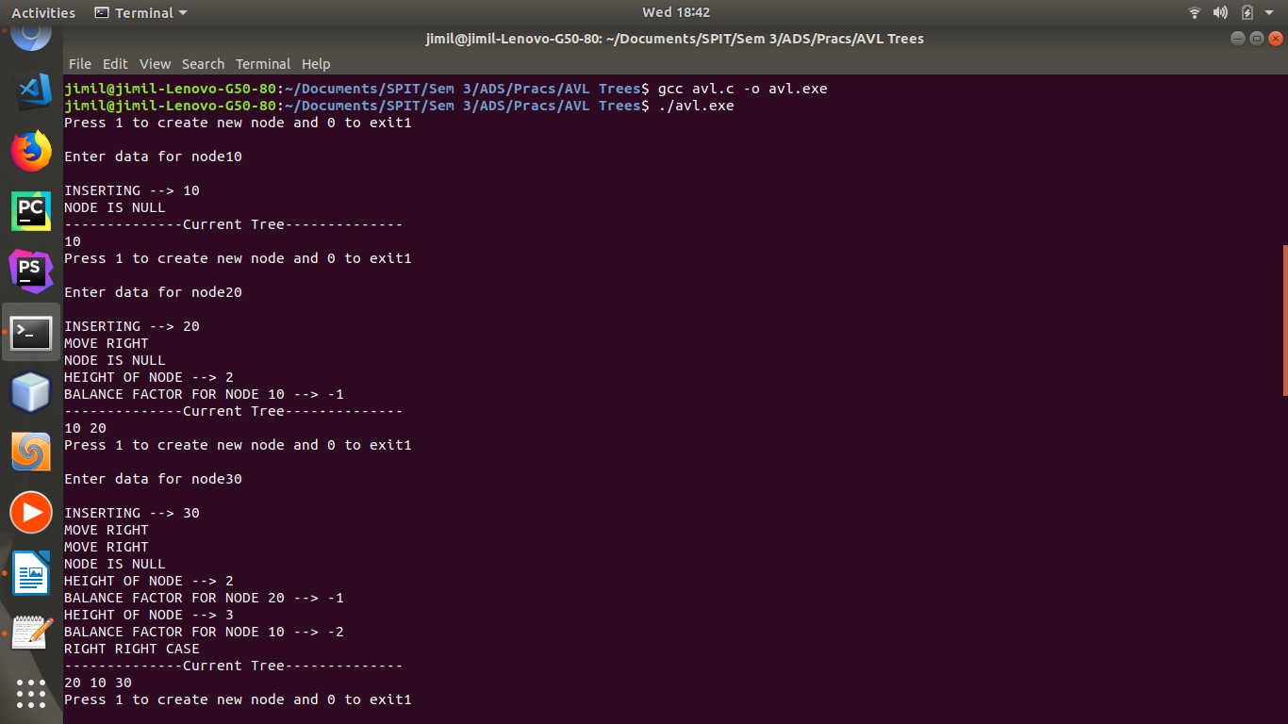Figure 3

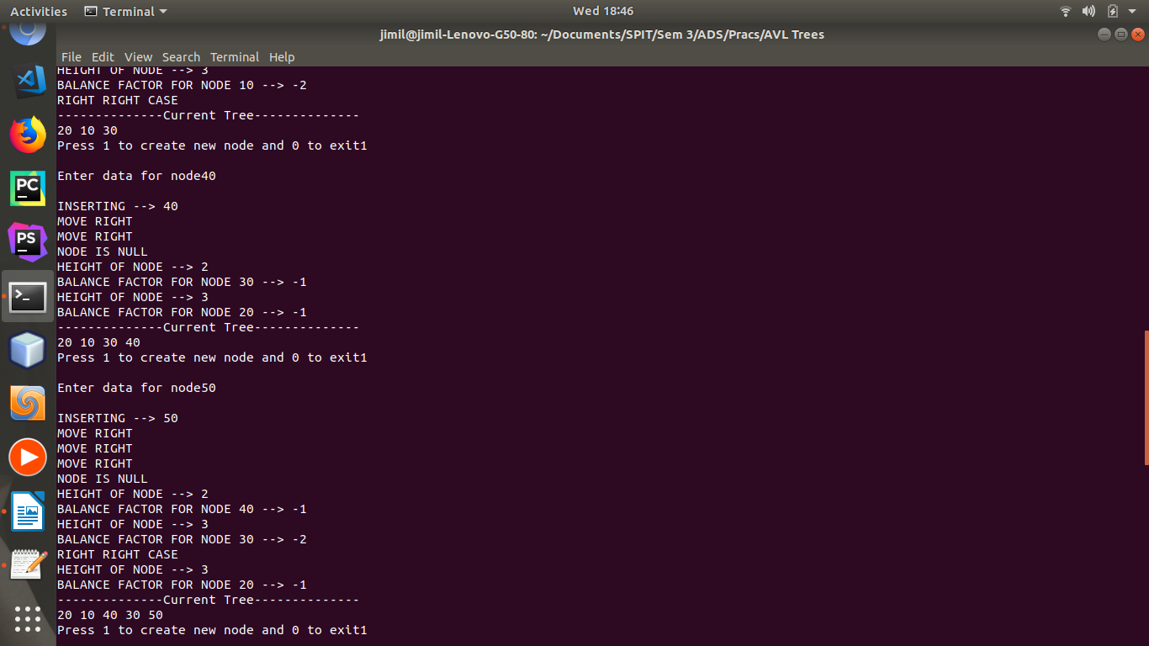Figure 4
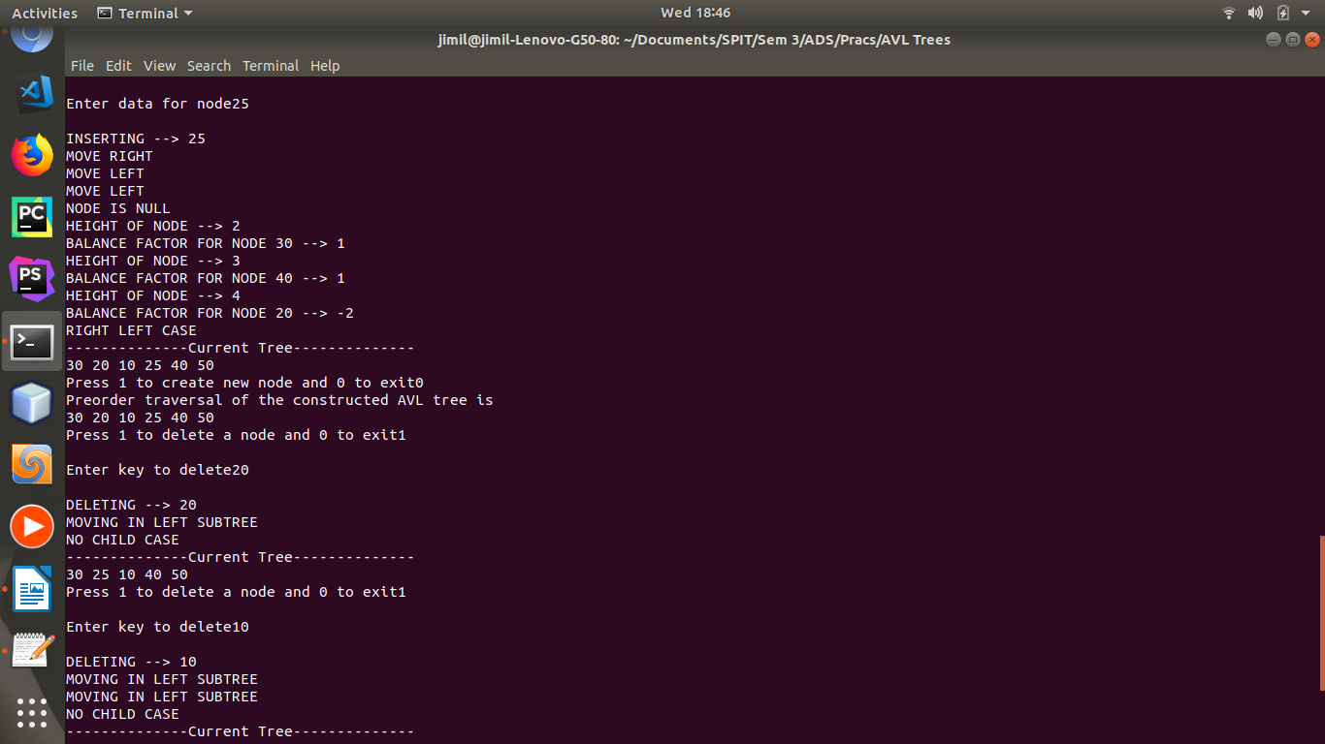Figure 5

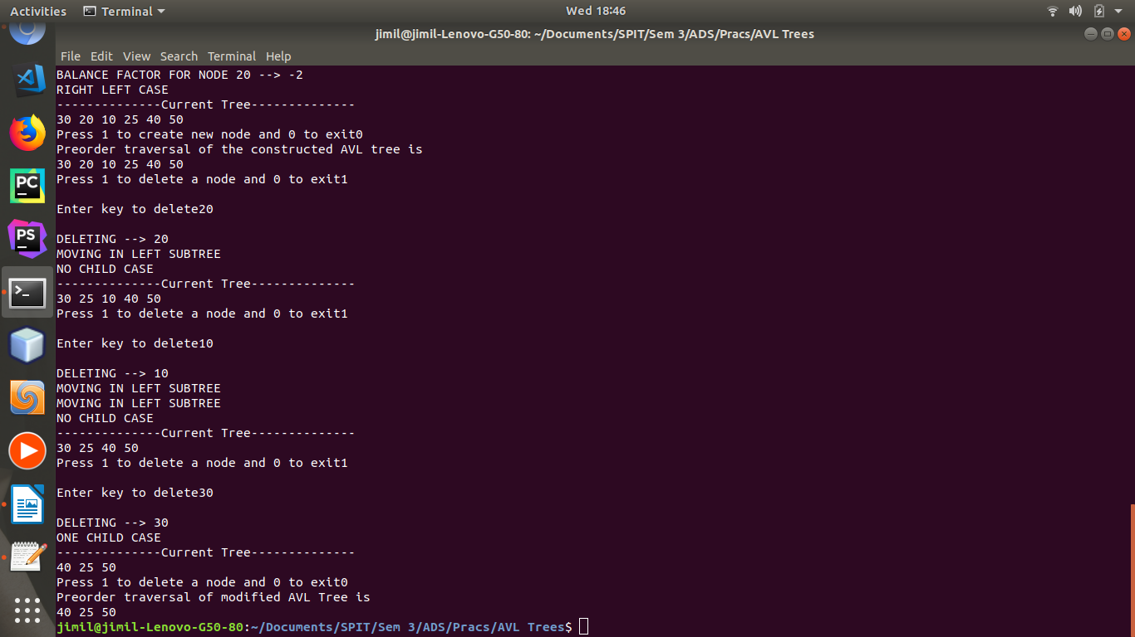Figure 6
Result:
Thus, we observed the working of a height balanced tree, and the insertion and deletion operations on it. On performing the various operations, we observed how the AVL tree self-balances itself by rotating appropriately, a subtree rooted at some particular node. The result was that all nodes were kept as close to the root as possible, and formation of skewed trees is prevented. This also ensures time and space enhancements.

Conclusion:
Thus, we have understood the concept of height-balanced trees or AVL trees, and implemented insertion and deletion operations on it.

